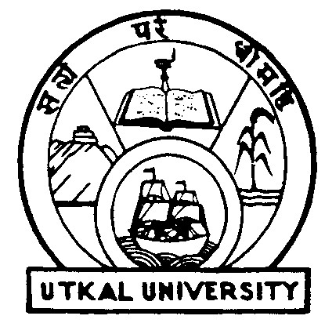UTKAL UNIVERSITY
Ability Enhancement Compulsory Course-I (AECC-I)

ENVIRONMENTAL SCIENCE

SEMESTER – I

FOR +3 ARTS, SCIENCE & COMMERCE - 2016

FULL MARKS: 100

TIME: 3 HOURS END SEMESTER: 80
TIME: 1 HOUR MID SEMESTER: 20

Unit - I
The Environment: The Atmosphere, Hydrosphere, Lithosphere, Biosphere, Ecology, Ecosystem, Biogeochemical Cycle (Carbon Cycle, Nitrogen Cycle).

Unit – II
Environment Pollution: Air Pollution, Water Pollution, Soil Pollution, Noise Pollution, Thermal Pollution, Radiation Pollution, Natural Disasters and their Management.

Unit – III
Population Ecology: Individuals, Species, Pollution, Community, Control Methods of Population, Urbanization and its effects on Society, Communicable Diseases and its Transmission, Non-Communicable Diseases.

Unit- IV
Environmental Movements in India: Grassroot Environmental movements in India, Role of women, Environmental Movements in Odisha, State Pollution Control Board, Central Pollution Control Board.

Unit – V

Natural Resources: Conservation of Natural Resources, Management and Conservation of Wildlife, Soil Erosion and Conservation, Environmental Laws: Water Act, 1974, Air Act, 1981, The Wildlife (Protection) Act, 1972, Environment Protection, 1986.

************

